***Fantasy Hurling Game with Social Media Capabilities***

Project Scope Document

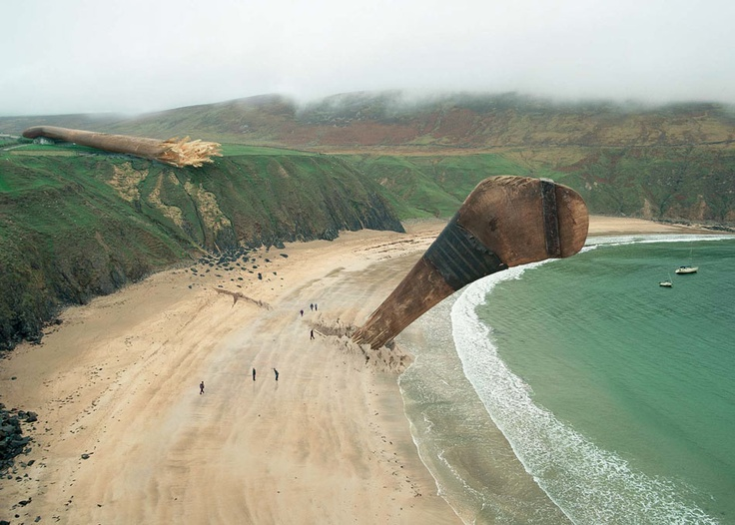

*Project Skills*

*Michael James*

*B00019330*

*29/09/2014*

Submitted in part fulfilment for the degree of

**B.Sc. (Hons) Computing**

School of Informatics and Engineering,

Institute of Technology Blanchardstown,

Dublin, Ireland

Contents

Declaration 3

Project Specifics 3

Project Name: 3

Project Supervisor: 3

Project Time Scale 3

Main project Objectives 4

Defining features and benefits 4

Work Breakdown Structure (WBS) 5

Assess project worth (Level 1 task) 5

Design phase 5

Implementation Phase 5

Testing Phase 5

Proposed Activity List (Task list for Gaant chart) 6

Phase 1 before Christmas 6

Phase 2 after Christmas 6

Gaant chart 7

Phase 1 7

Phase 2 Chart 7

Conclusion 8

# Declaration

I hereby certify that this material, which I now submit for assessment on the programme of study leading to the award of Degree of **Honours B.Sc. in Computer Science** in the Institute of Technology Blanchardstown, is entirely my own work except where otherwise stated, and has not been submitted for assessment for an academic purpose at this or any other academic institution other than in partial fulfilment of the requirements of that stated above.

# Project Specifics

## Project Name:

Fantasy Hurling Game with Social Media Capabilities

## Project Supervisor:

Luke Raeside

## Project Time Scale

29/09/2014 – 15/12/2014

### Main project Objectives

The main objectives for the project are to develop a working and stable site which users can use to play a fantasy hurling game. It will also have major social media capabilities. It will have the possibility of placing ads on the site to gain revenue. Each user will select a team with a total of no more than 100 Million in valuation from a list of players, all of the players have a value based on their ability and team. The user can register and create a profile which can be customised, this can then be used to go onto forums and discuss games with other users, or use the instant messaging application build in, and the GPS system outlined above. Each week after the games have been played, and administrator will be able to go into the application and update the players scores based on how they fared that week. The next time the user logs in, his overall score will be updated, along with his total position in the game from all players playing the game.

### Defining features and benefits

* The ability to create a unique fantasy hurling experience
* Social media to play a major part unlike all other apps of this type
* Great potential for advertising revenues
* User can have own profile which can be customized
* User can chat with other users unlike all other apps of this type
* Possible integration of an instant messaging area
* GPS built in to allow chat with users in a similar location
* Entering and updating of player scores based on real life games

# Work Breakdown Structure (WBS)

## Assess project worth (Level 1 task)

* Create list of project necessities (Level 2 Task)
* Check internet for technologies needed (Level 3 Task )
* Check copyright on technologies and official logos
* Check price on project necessities
* Decide on project worth doing or not

# Design phase

* Research design method and select one ( Level 1 task )
* Create specifications in detail ( Level 2 Task )
* Plan staff workload and duties ( Level 3 Task )
* Plan overall timescale
* Choose technologies to suit project
* Decide on web site visual design and logo
* Choose a project supervisor
* Determine if budget is enough

# Implementation Phase

* Write the code for the project ( Level 1 Task )
* Design the web site with HTML and CSS and JSON ( Level 2 Task )
* Logic written in JAVA
* Tie the two together with Java enterprise server and PHP
* Keep documentation up to date including diary ( Level 3 Task )

# Testing Phase

* Select a method of testing ( Level 1 Task )
* Check internet for suitable documentation to back up testing method ( Level 2 Task )
* Test project using JUNIT and other testing methods ( Level 3 Task )
* Roll out project

## Proposed Activity List (Task list for Gaant chart)

### Phase 1 before Christmas

1 List essential things needed

2 Check up on technologies we could use

3 Check copyrights

4 Check prices on any hardware we may need

5 Decide on whether or not to go ahead with project

6 Select a design method

7 Create detailed Spec

8 Plan staff workload and duty

9 Plan timescale

10 Choose technologies

11 Decide on site design

12 Choose a project Supervisor

13 Decide on a final budget

### Phase 2 after Christmas

14 Write Java code

15 Write HTML code for site

16 Tie together with Java enterprise Server

17 Assess Diary Documentation of each staff member

18 Select Testing methods

19 Test project

20 Roll out project

# Gaant chart

As this project is very much broken into two parts, one before Christmas and one after I have done out two separate Gaant charts to keep things as neat and easy to read as possible!

Week 1 starts October 1st and week 10 ends 14th December

Week 14 starts January 14th and week 34 ends in May when the final project is handed in

## Phase 1

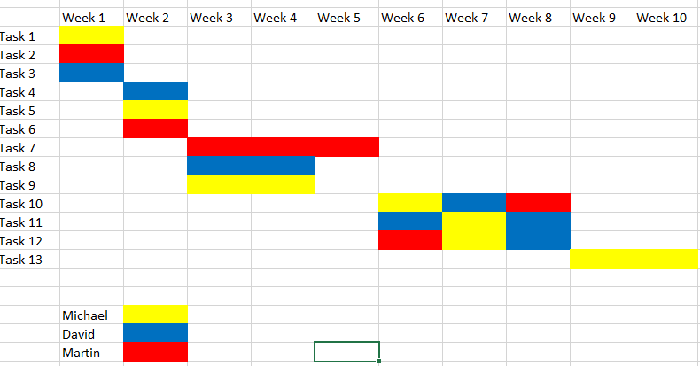

## Phase 2 Chart

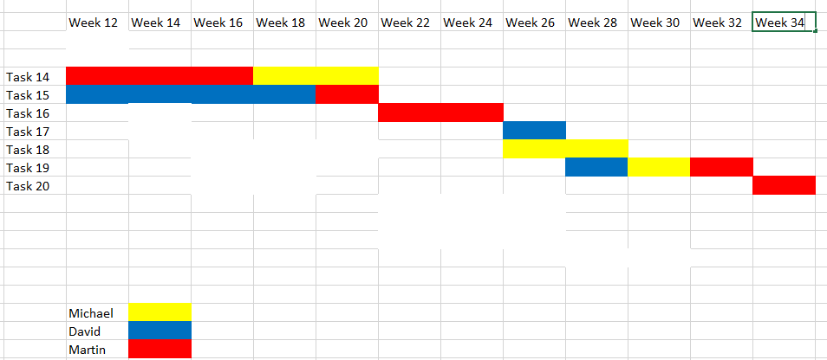

# Conclusion

The project we have chosen has substantial financial and social benefits. We feel it can exploit an area where there are currently no fantasy hurling games, despite the popularity of both hurling and these type of games, it seems an obvious thing to have out there, but it does not exist in a professional format as yet. The project is very much realistic based on the ability level and knowledge of each member of the team, and the budget and timeframe has been taken into account and we feel those are also in realistic proportions also. We will have some issues along the way and some working out of these even before we get to the implementation or testing phase will need to be done, but we are confident the final product will be of a standard that is acceptable for what our customer base would want and what we have outlined in our original proposal.